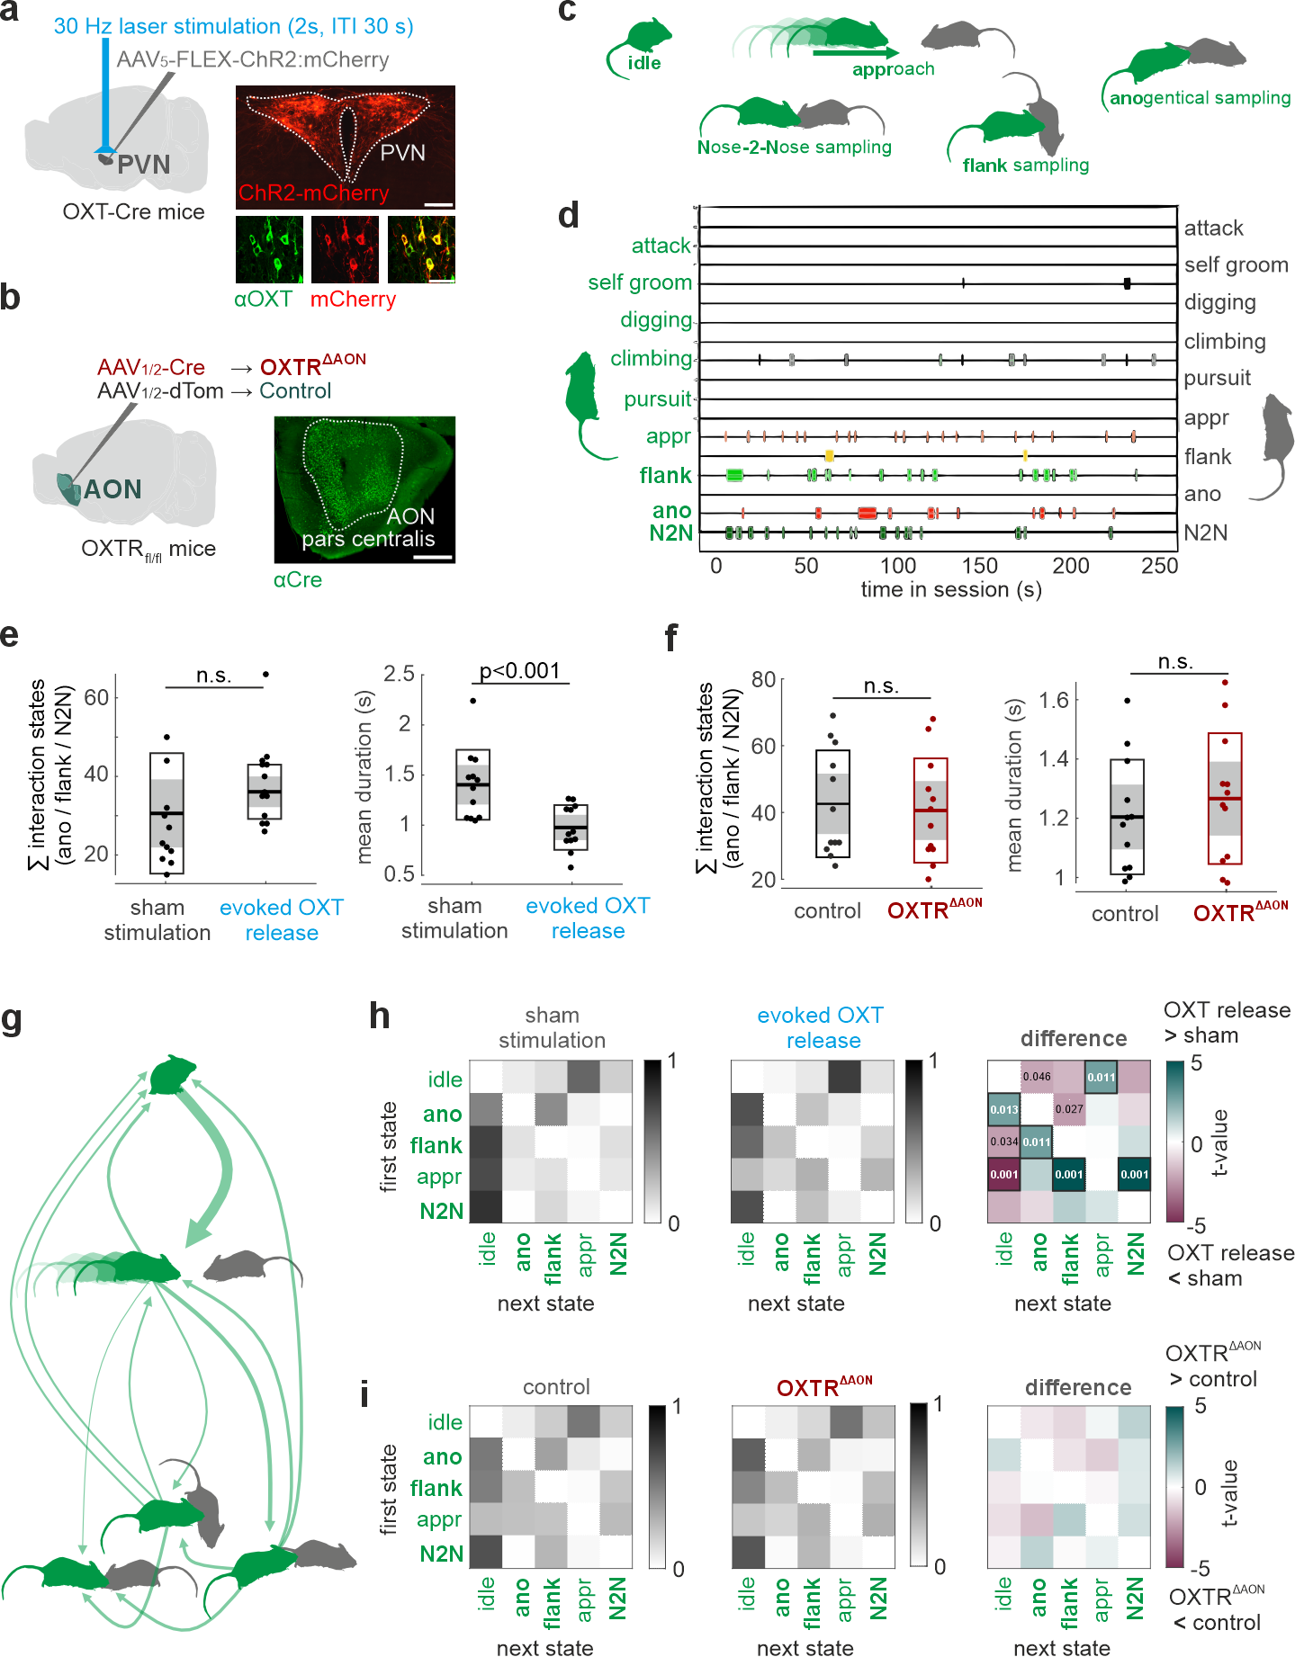
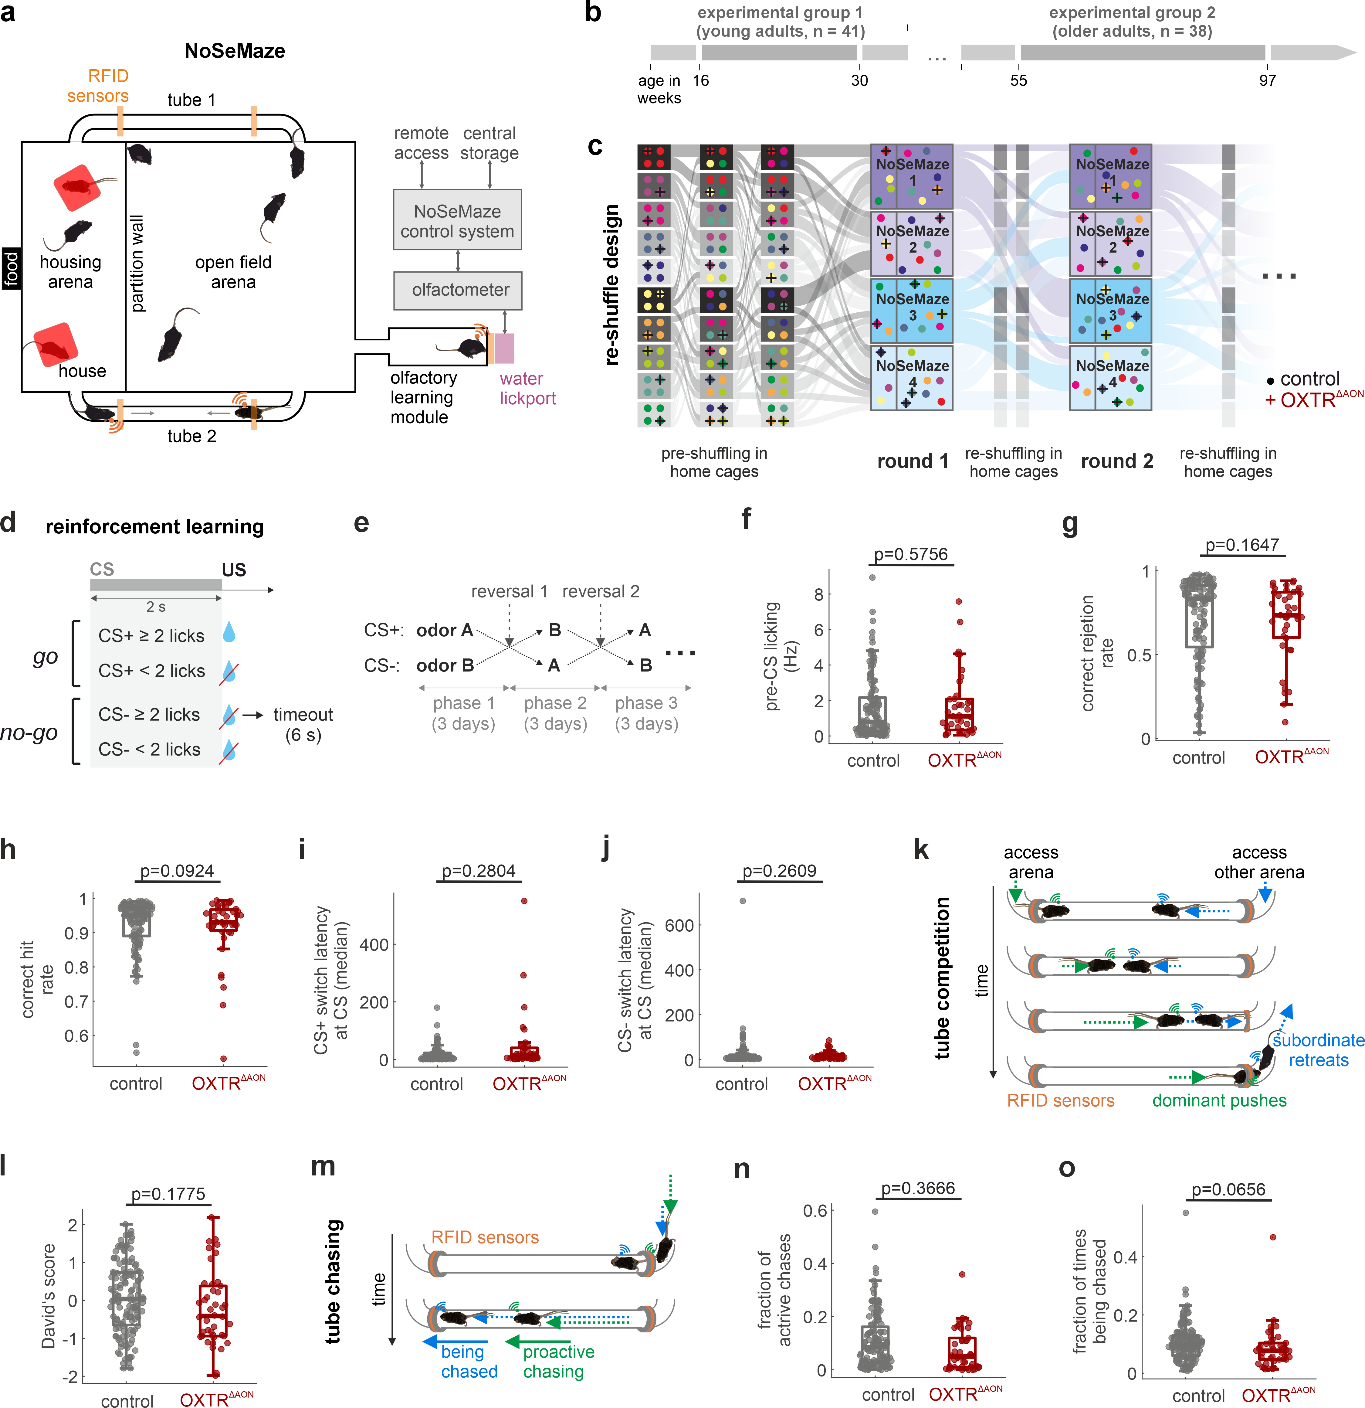
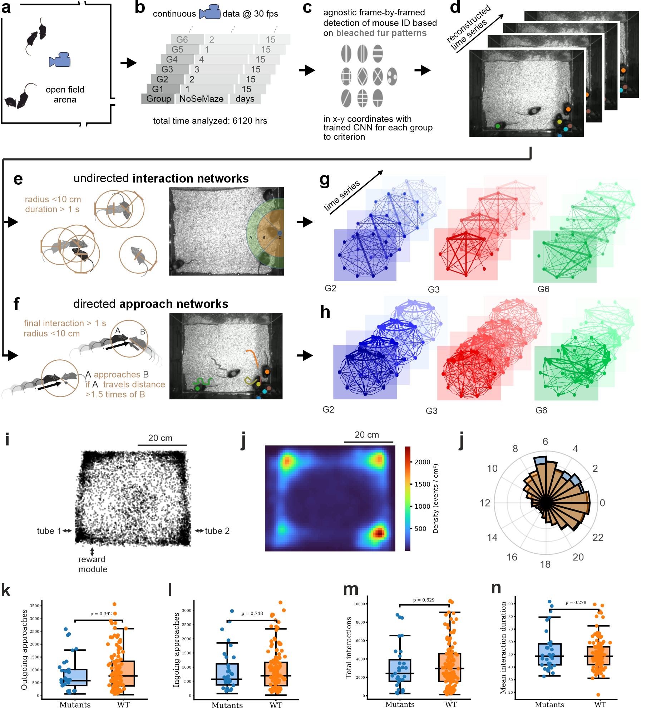
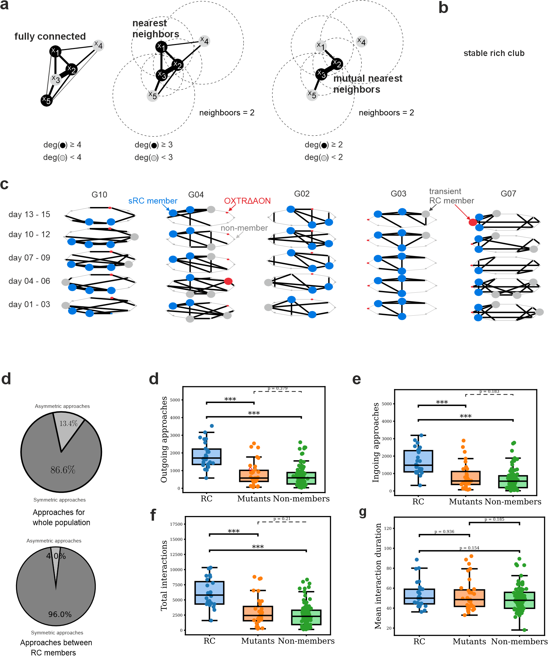
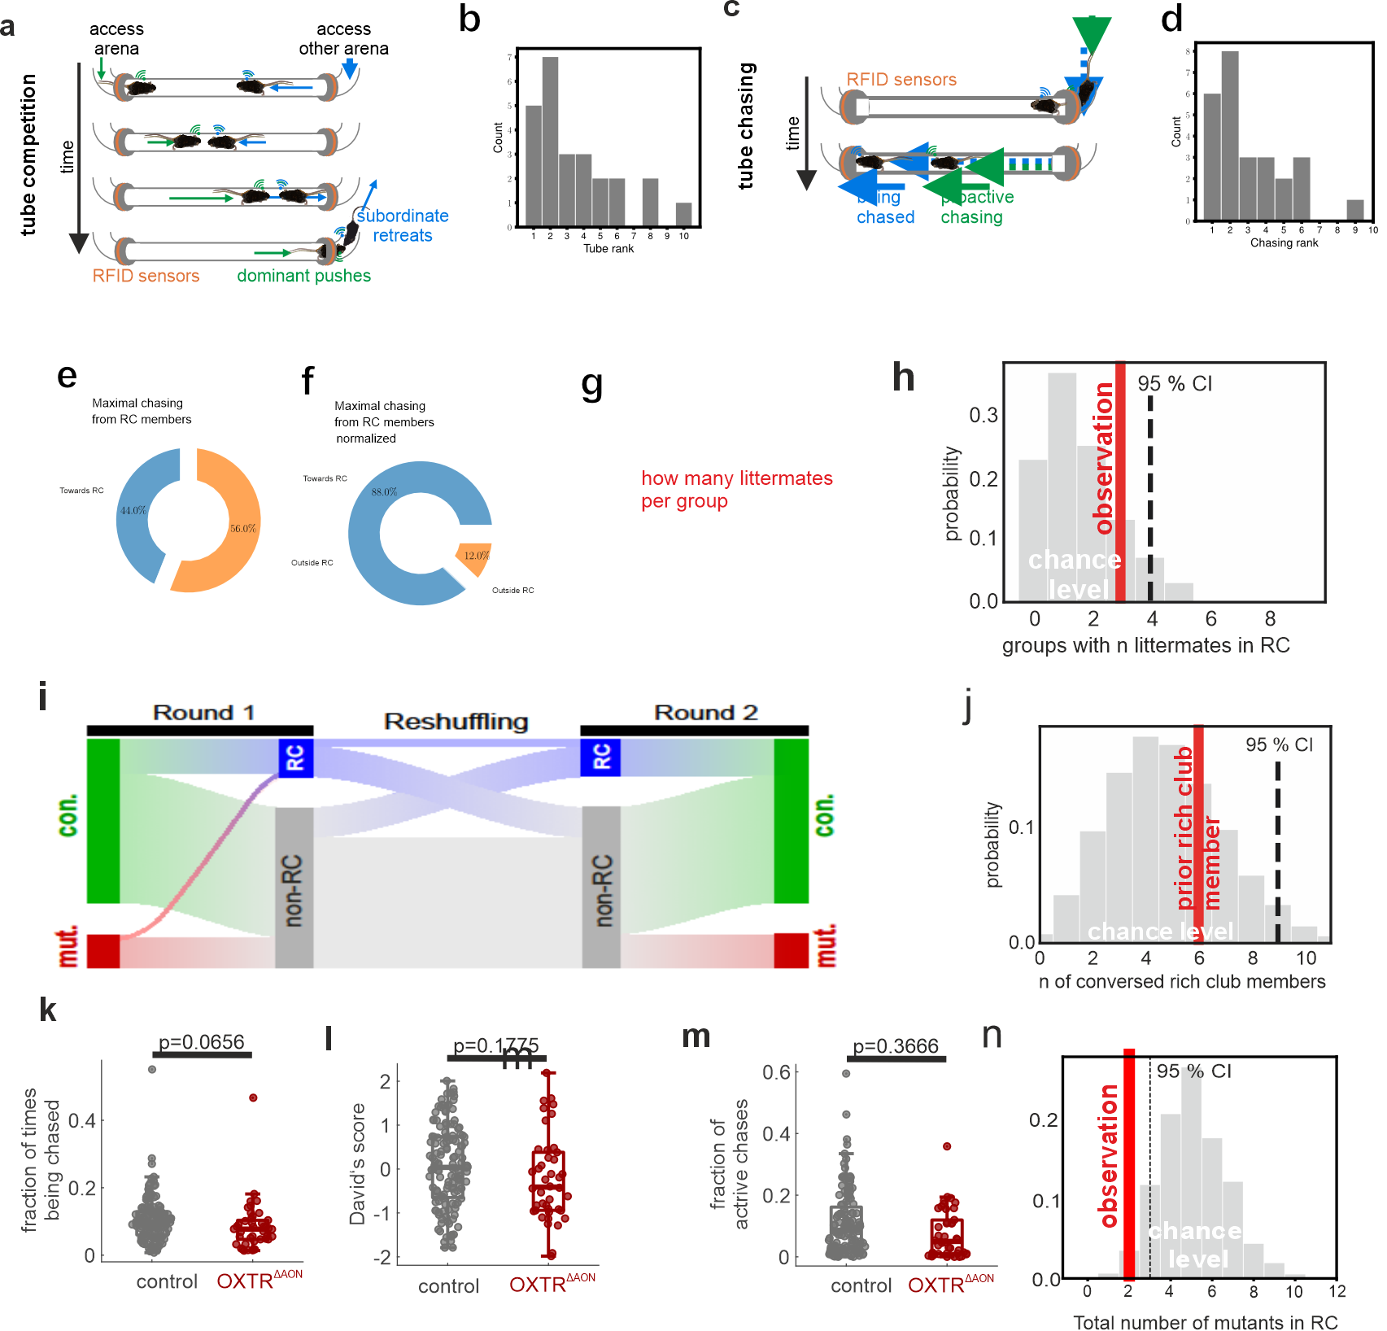
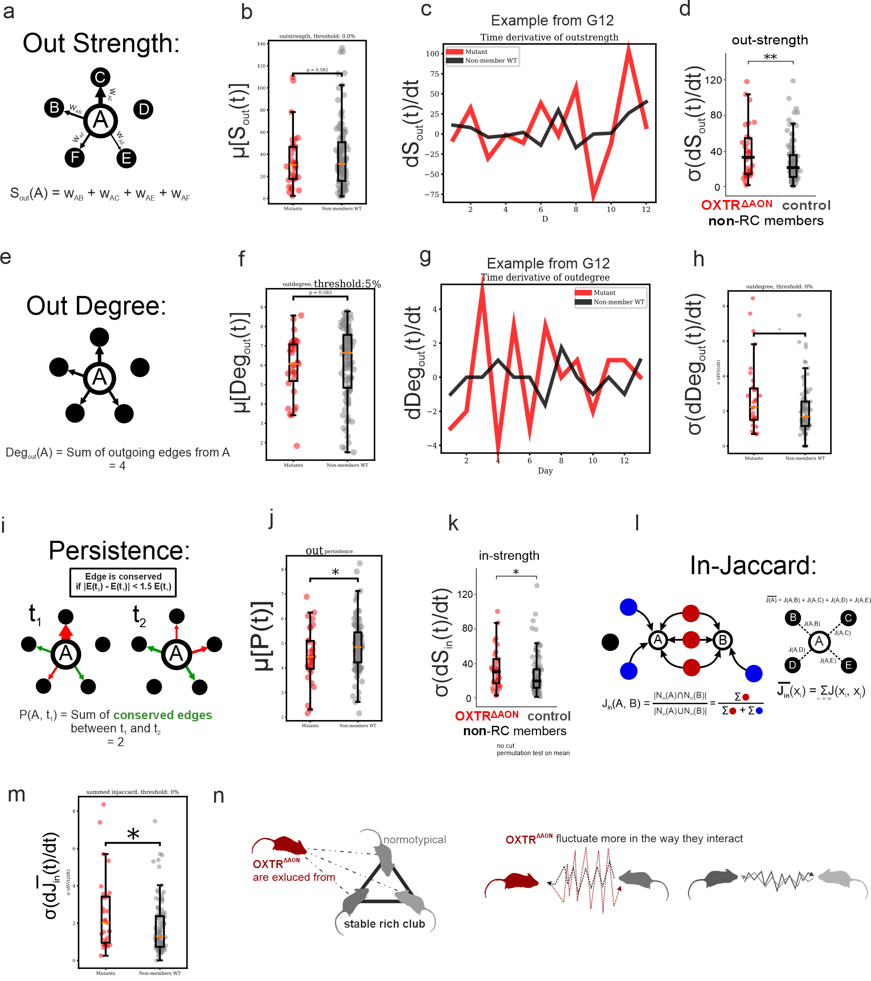
Title
De novo formations of stable cliques in mouse societies requires cortical cognitions enabled by oxytocin
De novo formations of stable cliques in mouse societies requires oxytocin enabled cortical cognitions

Authors
Corentin Nelias^{1,2,#}, Sarah Ghanayem^{1,2,#}, David Wolf^{1,2}, Marcel Moor¹, Max F. Scheller¹, Carla Filosa¹, Valery Grinevich², Jonathan R. Reinwald^{1,2,§}, Wolfgang Kelsch^{1,2,§,}*
¹ Dept. of Psychiatry and Psychotherapy, University Medical Center Mainz, Johannes-Gutenberg University, Untere Zahlbacher Strasse 8, 55131 Mainz, Germany
² Dept. of Psychiatry and Psychotherapy, Central Institute of Mental Health, Medical Faculty Mannheim, Heidelberg University, Square J5, 68159 Mannheim, Germany
# shared first authors, § shared last authors, * corresponding author: wokelsch@uni-mainz.de
Abstract
Stable and reciprocal relationships confer competitive advantages and are essential for higher-level social functioning, yet the neurobiological basis enabling this stability remains incompletely understood. Oxytocin in the anterior olfactory cortex modulates social cognition and recognition memory. Here, we examined how selective reduction of oxytocin receptor activity in this region affects social relationship formation in mice. Mutant mice displayed intact non-social olfactory learning and typical dyadic interaction patterns, suggesting a cognitive-specific deficit. To model sparse genetic variation in naturalistic settings, a small number of mutants were embedded in larger groups of neurotypical mice within a semi-naturalistic habitat. Social rank acquisition was largely intact, as was the density of self-initiated social approaches. However, network analysis revealed that while neurotypical mice formed “rich clubs”—highly interactive subgroups with stable mutual relationships—mutants failed to integrate into these subgroups. Their outgoing connectivity was less stable, even compared to neurotypical mice outside rich clubs. This was accompanied by diminished reciprocation from others and fluctuating social motivation of mutants themselves. The selective inability to form stable relationships parallels impairments observed in higher-functioning autism spectrum disorders, where individuals engage socially but struggle to form deep, reciprocal bonds. These deficits underscore the role of oxytocin in tuning sensory systems into a social cognition state, with profound implications for an individual's ability to establish stable relationships within social networks.

Introduction 474 words
The formation and maintenance of complex reciprocal social relationships requires intact social motivation and cognitive processes, such as sensory processing and social recognition. Difficulties in establishing stable interpersonal relationships are a hallmark of severe mental disorders and significantly contribute to impairments in everyday functioning[1, 2].
Structured social networks emerge from repeated interactions, leading to preferential associations that may stabilize into enduring dyads or complex affiliative subgroups [3]. However, the ability to form and maintain such de novo social relationships varies substantially across individuals in the general population. Importantly, such variations in higher-order social behavior may not necessarily manifest as reduced social interest or interaction frequency. Instead, they often reflect a diminished ability to occupy and maintain functional roles within complex social networks [4, 5]. High-functioning autism spectrum disorder (ASD), often conceptualized as an extreme expression along a continuum of typical social functioning (REF), exemplifies this dissociation. (REF). Individuals with ASD show impairments in forming stable new relationships across multiple domains of everyday life, even though social motivation is often preserved [6, 7]. These challenges become particularly relevant in adulthood, when social environments increase in complexity and require flexible integration into novel social networks. Difficulties in meeting such demands are associated with poor/adverse long-term psychosocial and economic outcomes [8].

Network theory provides a powerful framework for understanding the structural underpinnings of social cohesion. It highlights the critical role of tightly connected subgroups in maintaining network resilience and integrity [9]. While such structures are well-documented in real-world and digital social networks [10], the neurobiological mechanisms that support their formation and maintenance remain poorly understood. In graph theory, highly integrated social structures/configurations can be described as rich clubs (RC) and refer to subsets of nodes that are more densely interconnected with each other than would be expected by chance. These RCs form a tightly interconnected core within the network, supporting robust social functioning and exerting significant influence over information flow, social support, and integration (REFS). Identifying how individuals gain stable access to these high-value social structures may offer new insight into the subtle cognitive and neural underpinnings regulating social integration.
Across mammals, a key modulator of social cognition is oxytocin [11–15]. Its role in modulating social salience and group cohesion has led to therapeutic interest in ASD and related conditions characterized by social deficits [16, 17]. However, despite promising preclinical data, clinical trials of intranasal oxytocin have yielded inconsistent and often disappointing outcomes in socially complex settings. This discrepancy raises the question whether our mechanistic understanding of oxytocin function is sufficient [18, 19], particularly in the context of higher-order social behaviors.
Here, animal models may help. Rodent models have revealed that oxytocin supports a variety of region-specific functions in the brain, modulating not only de novo social salience and recognition but also motivation, trust, and selective bonding with partners or offspring (REFS). In sensory pathways, oxytocin increases the salience of social cues (REFS), thereby enabling social recognition memory. Under reductionist conditions, oxytocin receptor (OXTR) activation in the anterior olfactory nucleus (AON) increased social sensory salience (REF) [13, 15]. Mice with reduced OXT signaling in this region (OXTR^{∆AON}) are impaired in a specific form of social recognition at both the neuronal and cognitive level (REF). Yet, it remains unclear how this isolated deficit in social recognition under simplified conditions translates into impairments in more complex social behaviors.
Social networks are non-linear dynamical systems (). This has two implications. Firstly, certain phenotypes may not be detectable in simple dyadic interactions but instead represent emergent properties of higher-order social networks involving multiple individuals (REF). It can therefore be informative to directly compare behavior across simple and complex social conditions. Secondly, in such networks, a change in one individual (or ‘node’) may not only alter its own behavior but also modify the responses of other nodes, leading to dynamic feedback effects (REF). More specifically, this means that a social cognition impairment may remain undetected in isolated pairwise interactions, but become evident through actions and reactions of others within a dynamic social network of multiple individuals.
Given this, several requirements arise. Individuals should be tracked within larger groups over longer periods to allow social subnetworks to emerge, stabilize or dissolve. Group size significantly shapes social structure, with smaller groups (~4) often forming despotic hierarchies (REF) that are less pronounced in larger groups (~10 mice) (REF). To capture the context-dependent nature of social dynamics, individuals should be tested across varying peer configurations. Moreover, multiple domains of social behavior should be captured to put social relations into a comprehensive perspective. Finally, inspired by natural patterns of genetic variation within populations (REF), genetic manipulations should be limited to a minority of animals to ensure that neurotypical individuals continue to shape the dominant group dynamics.
To address these requirements on naturalistic experiments, we designed a non-invasive, sensor-rich platform (NoSeMaze) (REF), which is capable of continuously monitoring spontaneous social behavior in group-housed mice over extended periods. The system enables automated tracking of naturalistic interactions and the assessment of social network dynamics without experimenter intervention.
Using this platform, we sought to examine the neurobiological mechanisms underlying the formation and stabilization of rich-club (RC) structures in social networks, focusing specifically on the role of oxytocin (OXT) in modulating social salience and recognition. To this end, we interspersed a minority of mice with region-specific disruption of OXT signaling (OXTR^{∆AON}) into otherwise neurotypical groups. We employed a stepwise approach, moving from brief dyadic interactions to complex group networks observed over extended timescales. This design allowed us to test whether the phenotypes associated with OXTR^{∆AON} represent emergent properties of higher-order social networks.
Should'nt we disclose a bit more of the results in the introduction? Or is this not the style of the journal?
To meet the above requirements on naturalistic experiments, we designed a non-invasive sensor-rich maze (NoSeMaze) (REF). The NoSeMaze consists of an open-field arena equipped with 24/7 video monitoring of individuals labeled with identified by fur patterns and a housing arena with nesting material and free access to food (cf. Fig. 2A). These arenas are connected via two tubes equipped with multiple RFID readers for automated tracking of individual mice. Mice can perform ad libitum trials in an olfactory stimulus-outcome learning module to earn their daily water needs. The NoSeMaze thereby captures continuous three-weeks-rounds without experimenter intervention, but steady surveillance of the dynamics of multidimensional behavior of individuals and their interaction.

We aim here to better understand key factors including the underlying neurobiology of the formation and stabilization of RC. Specifically the role of OXT in social salience and recognition. We therefore interspersed mice carrying OXTR^{∆AON}. We chose a stepwise approach from brief simple dyadic interactions to complex larger social networks and their dynamics evolving over longer times. We thereby tested whether phenotypes of mice carrying OXTR^{∆AON} is an emergent properties of a complex network.

Results
OXTR deletion in the AON does not alter brief dyadic social interaction patterns
It is not known if loss of OXT signaling in the AON affects the microstructure of self-paced dyadic same-sex interactions. We therefore probed their interaction states and transitions between them in controlled conditions that allow for high resolution mapping of these behaviors (Fig. 1a,b). We benchmarked a cohort with selective adult deletion of OXTR in the AON (OXTR^{ΔAON} with bilateral injection of AAV_{1/2}-CBA-Cre in adult male OXTR_{fl/fl} mice) and its matched controls (Fig. 1c) against a cohort of mice with optogenetics-boosted global OXT release throughout the forebrain (AAV-mediated conditional ChR2 expression in the paraventricular nucleus of male OXT-Cre mice) and its matched controls (Fig.1d). As hypothesized, boosted OXT release led to a tendency toward more sampling events, with significantly shorter durations (Fig. 1e), suggesting subtle facilitation of interactions. In contrast, OXTR^{ΔAON} mice did not differ from controls in the number or duration of interaction states (Fig. 1f). Boosted OXT release led to more frequent transitions from approach into sampling behaviors and a decrease of aborted interactions after approaches were initiated (Fig. 1h), consistent with enhanced an social engagement. By contrast, OXTR^{ΔAON} mice showed no significant differences from matched controls in transition probabilities (Fig. 1i). Partner behavior remained unchanged across all groups (Supplementary Fig. 2), indicating no reactive effects during brief interactions.
In summary, selective deletion of OXTR in the AON did not alter dyadic social interaction behavior during brief interactions, consistent with OXT acting mainly on social cognition in this cortex. We therefore wondered what consequences the selective impairment in social cognition may have in complex and dynamic social networks.
Fig. 1

OXTR^{ΔAON} mice display quantitatively normal social activity in naturalistic group settings
To assess the social interaction dynamics in a complex naturalistic retaining control of complete tracking of individual behavior, we employed the NoSeMaze system (Reinwald et al., 2025). The NoSeMaze provides a semi-naturalistic sensor-rich environment enabling long-term, automated tracking of cognitive and social behaviors in group-housed mice without human interference (Fig. 2a). Groups of 9-10 RFID-chipped mice – each including two to four OXTR^{ΔAON} individuals interspersed among controls (total of 79 male mice (XX OXTR^{ΔAON} and XX control mice) – were monitored over continuous three week-rounds without experimenter intervention across. We tested separate subgroups of younger adults (16–30 weeks) and older adults (55–97 weeks) to assure that phenotypes were stable across the adult lifespan (Fig. 2b). To assess which social behaviors depend on specific group configurations, mice were live in in each round with different peers in the NoSeMaze (‘reshuffling’, Fig. 2b). Each group consisted of 8–10 individuals, with 1–4 OXTR^{ΔAON} mice interspersed among control mice to mimic naturalistic sparse genetic variation.

Fig. 2

We then established a pipeline to extracts the social interaction networks of the groups of individually identified mice including interspersed OXTR^{ΔAON} mutants from the continuous video data in the open field arena in 17 rounds total Fig. 3a-b). To identify each mouse, distinct patterns had been bleached in the fur on the back before the round (Fig. 3c). We analyzed the first 15 days of each round as fur regrew and pattern identification by the trained RNN became less reliably. Before the start of the next round the fur pattern was refreshed. Approx. 6.100 hours of continuous video data entered into the social networks (Fig. 3d).
The RNN-based pipeline outputted the spatial coordinates associated to the position of each animal as a function of time. From the tracked positions, we defined and extracted two different types of social events of interest: interactions and approaches. This allowed us to represent the data as a social network. Interactions, which yielded undirected networks, were counted whenever the distance between two animals was less than 10 cm for at least 1.0 second (Fig 3e). We defined approaches by calculating the distances travelled in the 4 seconds before the interaction for both interaction partners (Fig. 3f). If the ratio of travelled distances of mouse A to mouse B exceeded 1.5, mouse A was considered the approaching one. Otherwise, no approach was counted, for example in cases where they equally approached each other. Approaches performed between each mice yielded a directed network. We obtained stacks of 1-day undirected and directed networks (Fig. 3g-h). Spatially, interactions preferentially occurred closer to the walls of the open arena (Fig. 3i-j) and during the active dark cycle (Fig. 3k). Notably, OXTR^{ΔAON} and control mice displayed quantitatively similar number of interactions and event durations (Fig. 3l-m) as well as number of both ingoing and outgoing approaches (Fig. 3n-o), suggesting preserved approach behavior in mice carrying OXTR^{ΔAON}. We therefore tested the hypothesis that social cognition deficits affect the building of targeted and thus consistent social relationships.
Fig. 3

Stable rich clubs emerge in social networks of group-housed mice
While some social relationships may be instable dynamic and occur by chance or are not stabilized by reciprocal behaviors, others gain stability and persist for the time a group of animals live in the same habitat. We were particularly interested here in identifying the key factors that enable the formation of such stable reciprocal cliques within larger groups.
Interaction data were analyzed across five consecutive 3-day windows per round. Given the high baseline connectivity in the networks, graphs were pruned using a mutual nearest-neighbor algorithm to isolate stable and behaviorally relevant substructures (Fig. 4a; Supplementary Fig. X). In most cohorts (81%), we observed the emergence of stable, densely interconnected subnetworks composed of high-degree nodes. These structures represent rich clubs (RC; CITE, Fig. 4b–c). RCs that persisted across at least 4 out of 5 3-day-graphs were considered stable rich clubs (sRC). Notably, sRC were robustly identifiable in both undirected interaction and directed approach networks. Statistical modeling confirmed that such persistence was highly unlikely to occur by chance (p < 10⁻⁷ for pairs; p < 10⁻⁹ for triads), indicating genuine social structure.
sRC members displayed distinct interaction behaviors. Compared to non-members, they engaged in more interactions and approaches (Fig. 4d–f), although approach duration did not differ (Fig. 4g). Notably, OXTR^{ΔAON} mice behaved quantitatively similarly as non-members in these measures (Fig. 4d–g). sRC members also exhibited greater reciprocity: 96.0% of their approaches were reciprocal, compared to 67.7% in the general population (Fig. 4h). Thus, stable rich clubs form in most of the groups in the NoSeMaze and can be identified both from undirected interaction graphs and directional approach networks.
Fig. 4

Key factors that favor rich club membership
Stable RC membership came with differences in other social behaviors. In social rank networks derived from dyadic competitions in the tubes of the NoSeMaze (Fig. 5a, c.f. Reinwald et al., 2025), sRC members tended to be higher in hierarchy (Fig. 5b). The distribution of social ranks however had a large variance among sRC members, suggesting that high social rank might promote, but does not guarantee sRC membership. We also testes for proactive chasing of others through the tubes (Fig. 5c). sRC members initiate more chases than non-members (Fig. 5d). [[[TBD: Fig. 5e-f: how do we summarize the normalized and not inside and outside chasing? And, we have to say something about being chased.]]]
We next tested predictions on the nature of sRC. Firstly, sRC may emerge from the interplay among specific individuals. Thus, shared upbringing may not be a key factor when it comes to de novo formation of sRC in the adult in larger groups. Indeed, kinship (Fig. 2g) did not increase the likelihood to become a member in a sRC above random chance (Fig. 2h). Secondly, specific group configurations may mainly influence if an animal becomes part of the sRC more than prior membership experience. To test this, we took advantage of the reshuffling of the mice that configured different group compositions in consecutive rounds (Fig. 5i, cf. Fig. 2b). Among mice participating in multiple NoSeMaze rounds, the probability of re-entering a sRC did not exceed chance (Fig. 5j), suggesting that sRC membership is not an intrinsic individual attribute, but instead emerges de novo from the specific social dynamics within each group. Two other social behaviors, social rank and proactive chasing become however internalized in individuals and are largely maintained in different group configurations (Reinwald et al, 2025). Indeed, OXTR^{ΔAON} and normotypical mice differed neither in their mean hierarchy (Fig. 5k) nor in their expression of agonistic behavior (Fig. 5l-m).
In summary, most groups in the NoSeMaze form stable interconnected social structures that can be described as RCs. We found that mice in the RCs were significantly more active, engaged in more reciprocal interactions, and initiated more chasings than non-members. Owing to the fact that family relationships did not significantly influence rich club formation, and that most mice that entered the club did not integrate it again with new peers, we conclude that sRC formation is an emergent property reflecting the dynamic nature of the social interaction within each group.
OXTR^{ΔAON} mice fail to integrate into stable rich clubs
Since the formation of rich clubs in colonies appears to be a consequence of higher-order social interactions, a crucial question is whether OXTR^{ΔAON} mice enter them or not. OXTR^{ΔAON} mice have been shown to suffer from social cognition deficits. While these deficiencies did not lead to significant differences in the way mice partake in dyadic interactions (cf. Fig. 1 and 5h-i), it is very well possible that OXTR^{ΔAON} mice lack the capacity to engage in complex stable social relationships. To answer this question, we compared the number of OXTR^{ΔAON} mice that were able to enter the rich club to the one that would be expected by random chance using a bootstrap approach. The results (Fig. 5n) show that OXTR^{ΔAON} mice are significantly less likely to enter the sRC than control mice. In summary, OXT signaling in the AON plays a crucial role in the formation of social cliques that form de novo among mice in larger groups (cf. Fgi. 5i).
Fig. 5

Unstable network dynamics in OXTR^{ΔAON} mice hinder social integration
Although OXTR^{ΔAON} and control mice showed no differences in average measures of interaction time, approach frequency or social rank, OXTR^{ΔAON} mice failed to enter sRCs. To better understand the deficits emerging from this brain genotype, we analyzed how their social network connections behave as a function of time. Stronger fluctuation levels may explain the mutants’ inability to engage in stable relationships with others. Stronger fluctuations may explain the mutants’ inability to engage in stable relationships with others. Specifically, we examined fluctuations in directional approach networks, using the time derivatives of key graph metrics to assess instability. To avoid confounds from current RC membership, comparisons were made between OXTR^{ΔAON} mice and normotypic non-members, the latter of whom could nonetheless be sRC members in other rounds. We thereby isolated latent deficits specific to the OXTR^{ΔAON} phenotype.
We first focused on the stability of outgoing connections of mice carrying OXTR^{ΔAON}. Indeed, the outgoing strength (Fig. 7a–b) fluctuated significantly more in OXTR^{ΔAON} mice (Fig. 7c–d). Outgoing strength measures the total number of approaches performed by a mouse on the day independent of how many different mice were approached, thus reflecting also general social motivation (cf. Fig. 7a). In contrast, the out-degree measures the normalized intensity of approaches to other mice and thus is largely independent of the total number of approaches performed that day (Fig. 7e). Instability was also observed in out-degree, (Fig. 7f–h), supporting that while OXTR^{ΔAON} mice are socially active, their partner selection is more erratic.
To assess fluctuation levels in specific connections, we drew inspiration from the field of temporal graphs and propose a measurement that we call ‘persistence’ to study how connections between two partners are preserved in time. We define persistence as the number of preserved edges over time (see Fig 7i). Indeed, OXTR^{ΔAON} mice form less persistent edges than normotypical non-sRC-members (Fig 7j).
We next asked whether this instability also affects the way OXTR^{ΔAON} mice were perceived within the group. Fluctuations in ingoing strength were moderately higher in OXTR^{ΔAON} mice (Fig. 7k). A similar trend was observed for in-degree (Supplementary Fig. X). We therefore assessed how OXTR^{ΔAON} mice were socially embedded in the group by analyzing the time derivative of the in-Jaccard index, a network measure quantifying graph similarity that is the overlap in social partners over time (Fig. 7l). Indeed, this index fluctuated more strongly for OXTR^{ΔAON} mice (Fig. 7m), suggesting that their role within the group structure was less stable than that of controls. Together, these findings reveal that mice carrying OXTR^{ΔAON} not only initiate relationships less consistently, but also evoke more variable responses from peers (Fig. 7n).

Discussion 949 words
Our findings provide compelling evidence that oxytocin signaling in the anterior olfactory cortex modulates social cognitions that are crucial for the formation of stable social relationships in mice. Specifically, while OXTR^{ΔAON} mutants displayed intact social motivation and dyadic interactions, they failed to integrate into stable, highly interconnected social subgroups, or "rich clubs".
Deciphering the multiple roles of neuromodulators on social behavior requires investigating interactions at multiple levels of complexity [5]. Reductionist behavioral assays may not capture emergent social structures, as genotypic variations may only manifest in ecologically relevant conditions [19]. The NoSeMaze system allowed us to study self-paced interactions in freely moving mouse colonies, providing an opportunity to assess the supra-organismal effects of OXTR dysfunction at the network level. By interspersing a minority of mutants within a wild-type population, we mimicked sparse genetic variations found in natural societies while avoiding artificial shifts in collective behavior. This approach revealed that, despite displaying normal social approach behavior and intact dyadic interaction sequences, OXTR^{ΔAON} mutants exhibited profound impairments in forming structured social relationships.
This dissociation between simple social behaviors and higher-order social integration aligns with observations in high-functioning autism spectrum disorder (ASD) [6, 7], where individuals may engage in social interactions yet struggle to form deep, reciprocal bonds. Our results highlight the importance of studying complex behaviors beyond isolated social motifs, as deficits in structured social cognition may not be evident when considering only basic interaction frequencies [2].
Rich clubs represent a fundamental aspect of social network organization in both humans and animals [9, 17, 20], forming stable hubs within social systems. Our findings demonstrate that normotypic mice generally establish rich clubs shortly after being introduced into a social environment and maintain membership over time. However, these structures are not intrinsic to individuals but may emerge from group-specific dynamics [10], as evidenced here by the fact that previous rich club members were not more likely to re-enter a rich club when introduced to a new social group. This suggests that structured social bonding is an adaptive and situationally learned process rather than a fixed individual trait.
Notably, OXTR^{ΔAON} mutants failed to enter rich clubs despite exhibiting typical social hierarchy positioning. This suggests that rich club formation relies on oxytocin-dependent social learning [13, 15], reinforcing the notion that stable, reciprocal social bonds require cognitive processes beyond mere social engagement. This distinction between social rank and structured social relations parallels human social hierarchies [21], where status may facilitate but does not determine the ability to form close, reciprocal relationships.
The differential effects of OXTR^{ΔAON} deletion on social rank and rich club membership indicate that these two aspects of social behavior are governed by distinct mechanisms. Social rank, which remained intact in mutants, appears to be an internalized trait, learned through past experiences and maintained across different social groups. In contrast, rich club membership requires continuous social learning and the ability to form and retain structured relationships in novel environments. The observed preservation of social rank despite deficits in structured social bonding highlights a role of oxytocin in enabling dynamic, reciprocal social learning rather than establishing fixed social traits. Given that OXTR was deleted in adulthood, all mice had the opportunity to acquire social rank during development.
The inability to form new, stable social relationships in novel environments is a key feature of ASD and other social disorders [7, 8]. Many individuals with ASD function well in rigid, structured environments but struggle with flexible, self-directed social interactions [22], particularly in forming friendships. This deficit often only becomes apparent in adolescence or adulthood when individuals face increased social complexity [23]. Our findings suggest that selectively impairing oxytocin signaling in a cortex that contributes to social cognition, exhibits a comparable phenotype. The oxytocin signaling in this sensory cortical region is critical for the cognitive processes that underpin de novo social bonding rather than simply facilitating social approach behavior. Mice with OXTR^{ΔAON} engage in social interactions but fail to build structured relationships in novel group settings.
Notably, OXTR^{ΔAON} mice maintained a normal intensity of approaches to others in the maze; however, their approaches fluctuated substantially more, even compared to normotypic mice not in a rich club. Importantly, social networks are dynamic systems, where altered behavior in one individual can affect others' behavior [10, 24]. Indeed, we observed that others connected to the mutants interacted with them in a less stable fashion. Such social impairments exist along a continuum in the general population [25], influencing personal and professional outcomes [26]. By identifying a neural mechanism underlying these deficits, our study provides a framework for investigating interventions that enhance social network integration.
By integrating molecular, network, and behavioral analyses, our study advances understanding of complex social behaviors in genetically tractable mammalian models. The NoSeMaze system offers a novel method for studying social cognition under ecologically relevant conditions. Our findings underscore the need for therapeutic strategies that target social processing deficits. These results pave the way for future research into oxytocin’s role in structured social integration, particularly in the context of neurodevelopmental disorders. The platform may help to disentangle oxytocin’s multifaceted functions in different modulated brain regions on social cognition, but also on social motivation and other aspects [16, 17]. It will also allow investigate how direct and compensatory effects of early-life oxytocin disruptions influence social rank acquisition and whether targeted interventions can restore structured social bonding in affected individuals [12, 27].
In conclusion, our study demonstrates that oxytocin is essential for the formation of structured, reciprocal social relationships, rather than simply enabling social interactions. While OXTR^{ΔAON} mutants exhibited intact social motivation and dyadic interactions, they were unable to integrate into stable social subgroups, highlighting oxytocin’s role in supporting higher-order social cognition. These findings provide critical insight into the neurobiology of social network formation and may inform the development of targeted interventions for individuals with social impairments, such as those observed in ASD and other psychiatric conditions.
OR
Difficulties in forming and sustaining stable, reciprocal social relationships are a hallmark of several neurodevelopmental and psychiatric disorders, including high-functioning autism spectrum disorder. These deficits often emerge not as a lack of social interest, but as an impaired ability to integrate into complex social networks over time. Our findings demonstrate that selective disruption of oxytocin signaling in the anterior olfactory nucleus impairs the formation of stable affiliative bonds in socially rich environments, despite preserved basic social motivation and dyadic interaction patterns. This dissociation between social engagement and network integration mirrors clinical observations and underscores the need to assess social cognition within ecologically valid, group-level contexts. By linking specific circuit-level disruptions to higher-order social outcomes, this work advances our understanding of how subtle cognitive impairments translate into real-world social dysfunction, and may inform more targeted interventions for individuals with context-dependent social deficits.
Where do we add increasing complexity [28]

References
1. Adolphs R. The social brain: neural basis of social knowledge. Annu Rev Psychol. 2009;60:693–716.
2. Frith CD, Frith U. The neural basis of mentalizing. Neuron. 2006;50:531–534.
3. Kappeler PM, Clutton-Brock T, Shultz S, Lukas D. Social complexity: patterns, processes, and evolution. Behav Ecol Sociobiol. 2019;73:5.
4. Bicks LK, Yamamuro K, Flanigan ME, Kim JM, Kato D, Lucas EK, et al. Prefrontal parvalbumin interneurons require juvenile social experience to establish adult social behavior. Nat Commun. 2020;11:1003.
5. Insel TR. The challenge of translation in social neuroscience: a review of oxytocin, vasopressin, and affiliative behavior. Neuron. 2010;65:768–779.
6. Chevallier C, Kohls G, Troiani V, Brodkin ES, Schultz RT. The social motivation theory of autism. Trends Cogn Sci. 2012;16:231–239.
7. Pelphrey KA, Carter EJ. Brain mechanisms for social perception: lessons from autism and typical development. Ann N Y Acad Sci. 2008;1145:283–299.
8. Howlin P, Goode S, Hutton J, Rutter M. Adult outcome for children with autism. J Child Psychol Psychiatry. 2004;45:212–229.
9. van den Heuvel MP, Sporns O. Rich-club organization of the human connectome. J Neurosci Off J Soc Neurosci. 2011;31:15775–15786.
10. Centola D. The spread of behavior in an online social network experiment. Science. 2010;329:1194–1197.
11. Donaldson ZR, Young LJ. Oxytocin, vasopressin, and the neurogenetics of sociality. Science. 2008;322:900–904.
12. Marlin BJ, Mitre M, D’amour JA, Chao MV, Froemke RC. Oxytocin enables maternal behaviour by balancing cortical inhibition. Nature. 2015;520:499–504.
13. Oettl L-L, Ravi N, Schneider M, Scheller MF, Schneider P, Mitre M, et al. Oxytocin Enhances Social Recognition by Modulating Cortical Control of Early Olfactory Processing. Neuron. 2016;90:609–621.
14. Ferguson JN, Young LJ, Hearn EF, Matzuk MM, Insel TR, Winslow JT. Social amnesia in mice lacking the oxytocin gene. Nat Genet. 2000;25:284–288.
15. Wolf D, Hartig R, Zhuo Y, Scheller MF, Articus M, Moor M, et al. Oxytocin induces the formation of distinctive cortical representations and cognitions biased toward familiar mice. Nat Commun. 2024;15:6274.
16. Guastella AJ, MacLeod C. A critical review of the influence of oxytocin nasal spray on social cognition in humans: evidence and future directions. Horm Behav. 2012;61:410–418.
17. Yamasue H, Okada T, Munesue T, Kuroda M, Fujioka T, Uno Y, et al. Effect of intranasal oxytocin on the core social symptoms of autism spectrum disorder: a randomized clinical trial. Mol Psychiatry. 2020;25:1849–1858.
18. Bethlehem R a. I, Lombardo MV, Lai M-C, Auyeung B, Crockford SK, Deakin J, et al. Intranasal oxytocin enhances intrinsic corticostriatal functional connectivity in women. Transl Psychiatry. 2017;7:e1099.
19. Leng G, Ludwig M. Intranasal Oxytocin: Myths and Delusions. Biol Psychiatry. 2016;79:243–250.
20. Saramäki J, Kivelä M, Onnela J-P, Kaski K, Kertész J. Generalizations of the clustering coefficient to weighted complex networks. Phys Rev E Stat Nonlin Soft Matter Phys. 2007;75:027105.
21. Meyer-Lindenberg A, Domes G, Kirsch P, Heinrichs M. Oxytocin and vasopressin in the human brain: social neuropeptides for translational medicine. Nat Rev Neurosci. 2011;12:524–538.
22. Baron-Cohen S. Theory of mind and autism: A review. Int. Rev. Res. Ment. Retard., vol. 23, Academic Press; 2000. p. 169–184.
23. Mundy P, Rebecca Neal A. Neural plasticity, joint attention, and a transactional social-orienting model of autism. Int. Rev. Res. Ment. Retard., vol. 23, Academic Press; 2000. p. 139–168.
24. Christakis NA, Fowler JH. Connected: The Surprising Power of Our Social Networks and How They Shape Our Lives. Hachette UK; 2009.
25. Cacioppo JT, Cacioppo S. Social Relationships and Health: The Toxic Effects of Perceived Social Isolation. Soc Personal Psychol Compass. 2014;8:58–72.
26. Holt-Lunstad J, Smith TB, Layton JB. Social Relationships and Mortality Risk: A Meta-analytic Review. PLOS Med. 2010;7:e1000316.
27. Hammock EAD, Young LJ. Oxytocin, vasopressin and pair bonding: implications for autism. Philos Trans R Soc Lond B Biol Sci. 2006;361:2187–2198.
28. Cisek P, Green AM. Toward a neuroscience of natural behavior. Curr Opin Neurobiol. 2024;86:102859.

